**Salesforce Technical Documentation For Laptop Rentals CRM Application**

**1. Introduction**

**1.1 Overview**

Salesforce is a **cloud-based Customer Relationship Management (CRM) platform** that enables organizations to manage customer data, streamline business processes, and enhance customer engagement. In the context of the **Laptop Rentals CRM Application**, Salesforce acts as the core platform to manage customer inquiries, rental agreements, asset tracking, service requests, and communications (emails, reminders, follow-ups).

This project leverages Salesforce’s **Sales Cloud, Service Cloud, and Marketing.**

**1.2 What is Salesforce?**

Salesforce is a **Customer Success Platform** designed to manage **sales, service, marketing, analytics, and customer engagement** in one integrated solution.

With Salesforce, the Laptop Rentals business can:

* **Sell smarter** → Track potential customers, rental opportunities, and close deals faster.
* **Serve customers better** → Manage customer support requests, warranty claims, or laptop replacement requests.
* **Automate processes** → Reduce manual efforts by automating email communication, reminders, and rental renewals.
* **Access data anywhere** → Salesforce’s cloud infrastructure ensures that customer and rental data is available securely from any location.

**1.3 Salesforce Capabilities for Laptop Rentals CRM**

For this project, Salesforce provides the following core features:

1. **Sales Cloud**
   * Customer database management (Leads, Accounts, Contacts).
   * Opportunity management for laptop rental deals.
   * Pipeline tracking for new rental requests.
2. **Service Cloud**
   * Case management for customer issues (repairs, replacements, billing).
   * Knowledge base for FAQs (rental terms, pricing, policies).
   * Omni-channel support (chat, email, phone).
3. **Marketing Cloud / Email Studio**
   * Personalized email campaigns to potential customers.
   * Automated reminders for rental renewal or payment.
   * Customer segmentation for targeted promotions.
4. **Custom Objects for Laptop Rentals**
   * **Laptop Inventory Object** → Tracks available laptops, specifications, and rental status.
   * **Rental Agreement Object** → Manages rental contracts, start/end dates, payment terms.
   * **Delivery & Return Tracking Object** → Monitors delivery and pickup of laptops.
5. **Automation & Analytics**
   * Workflow rules, Process Builder, and Flow automation for approvals and notifications.
   * Reports & Dashboards for real-time visibility into rentals, revenue, and customer satisfaction.

## 2. Creating Developer Account

### 2.1 Purpose

A **Salesforce Developer Edition (DE) org** is a free, fully-featured environment provided by Salesforce for learning, development, and testing purposes. For the Laptop Rentals CRM Application, the Developer Org will serve as the **sandbox** where we configure, customize, and test CRM features before deploying them into a production environment.

### 2.2 Steps to Create a Developer Org

#### Step 1: Navigate to Signup Page

* Open your browser and go to [Salesforce Developer Signup](https://developer.salesforce.com/signup).

#### Step 2: Fill in Signup Form

Provide the following details on the registration form:

1. **First Name & Last Name**
   * Enter your personal name. Example: Sahith Bukkapatnam.
2. **Email Address**
   * Enter a valid email address where Salesforce can send your account verification link.
   * Example: 22kd1a0532@lendi.edu.in.
3. **Role**
   * Select **Developer** from the dropdown.
4. **Company**
   * Enter your **College Name** or Organization.
   * Example: Lendi Institute of Engineering and Technology.
5. **Country**
   * Select **India**.
6. **Postal Code**
   * Enter your **PIN code**. Example: 535003.
7. **Username**
   * Must be in the format of an **email address** but doesn’t have to be a real email.
   * Use a combination of your name + company.
   * Example: 22kd1a0532@lendi.

#### Step 3: Submit Registration

* Click **Sign Me Up** after filling the form.

#### Step 4: Verify Email

* Salesforce will send a **verification email** to the email address you entered.
* Open your inbox, find the email from Salesforce, and click the **Verify Account** link.

#### Step 5: Set Password & Security Question

* Create a **strong password**.
* Choose a **security question** and answer (for future account recovery).

### 2.3 Accessing the Developer Org

* After successful registration, you can log in at https://login.salesforce.com.
* Enter your **Username** and **Password** created during signup.

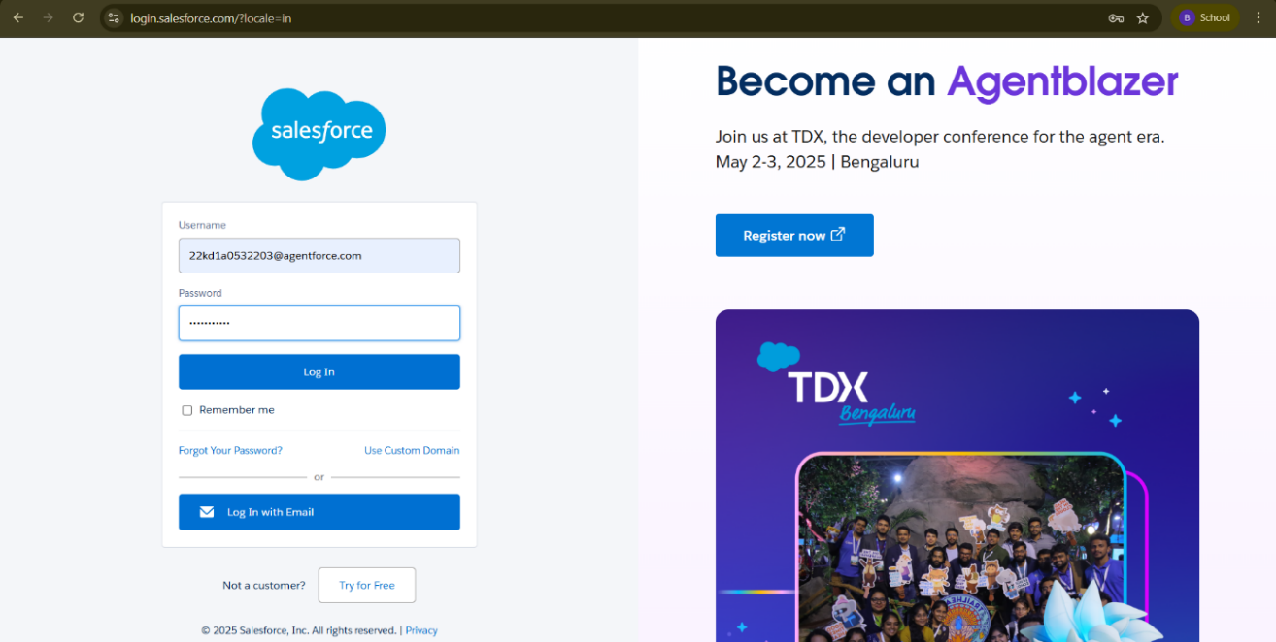

## 3. Account Activation

### 3.1 Purpose

After signing up for a Salesforce Developer Edition (DE) org, the account must be activated through email verification. This ensures that the email provided during signup is valid and linked to your Salesforce org. Without activation, you cannot access the Salesforce environment.

### 3.2 Steps to Activate Developer Account

#### Step 1: Check Email Inbox

* Open the **email inbox** of the account you used during Salesforce Developer signup.
* Look for an email from **Salesforce** with the subject line “Welcome to Salesforce – Verify Your Account”.
* Note: The email may take **5–10 minutes** to arrive. If not received, check your **spam/junk folder**.

#### Step 2: Verify Account

* Open the email.
* Click on the **Verify Account** button or link provided in the email.

#### Step 3: Set Password & Security Question

* After clicking verify, you’ll be redirected to the Salesforce **Account Setup** page.
* Enter a **strong password** (at least 8 characters, including one uppercase, one lowercase, one number, and one special character).
* Choose a **security question** from the dropdown list and provide your answer. This will be used for account recovery.
* Click **Change Password**.

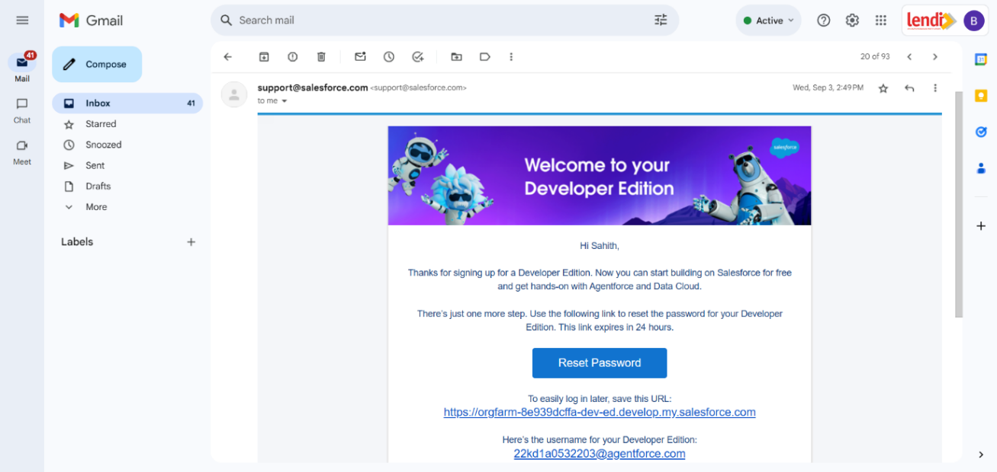

#### Step 4: Redirect to Salesforce Setup Page

* Once the password is set, Salesforce will log you into your **Developer Org**.
* You will be redirected to the **Salesforce Home Page** (Lightning Experience).
* From here, you can access the **Setup Menu** (gear icon ⚙️ at the top-right) to start configuring your org.

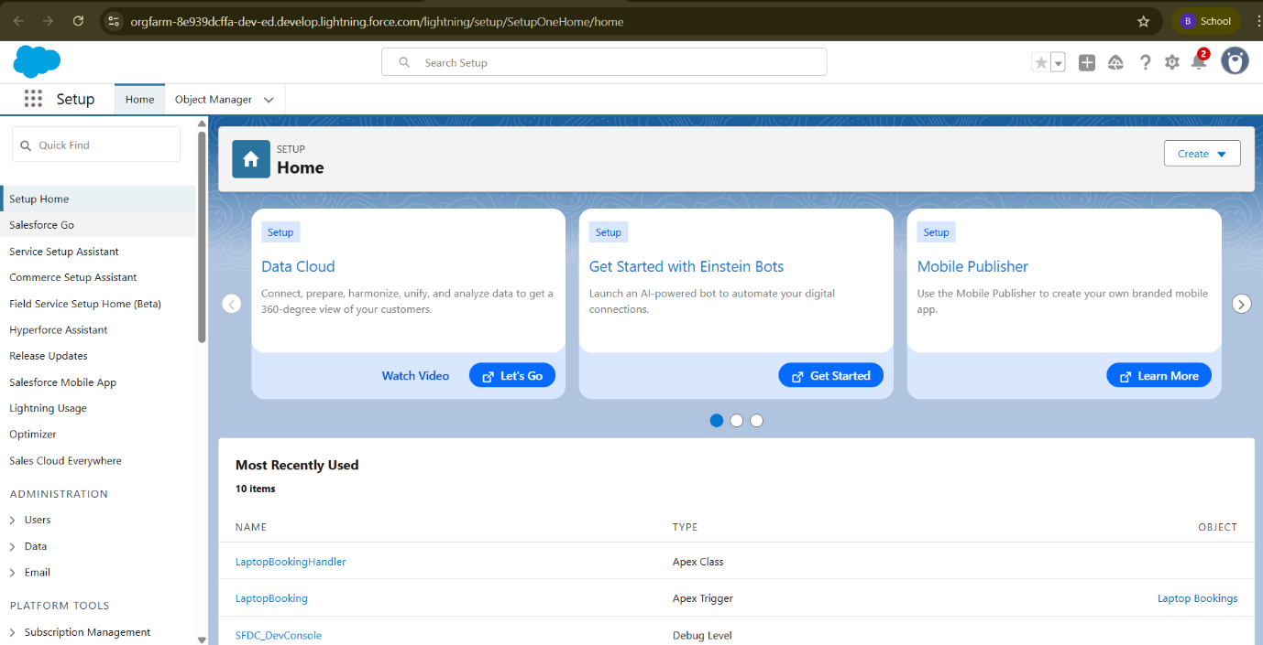

**4. Object Creation**

**4.1 What Is an Object?**

In Salesforce, an **Object** is a database table that stores information related to the organization. Objects contain **records (rows)** and **fields (columns)** similar to a traditional database. They are the foundation of data modeling in Salesforce.

**4.2 Types of Salesforce Objects**

1. **Standard Objects**
   * Predefined by Salesforce.
   * Used for general CRM operations like customer management and sales tracking.
2. **Custom Objects**
   * Created by users to store organization-specific data.
   * Provide flexibility for unique business needs.
   * In the Laptop Rentals CRM, examples include:

**4.3 Navigation to Setup Page**

* Click the **Gear Icon (⚙️)** in the top-right corner.
* Select **Setup**.
* You will be redirected to the Salesforce **Setup Home Page**.

**4.4 Steps to Create a Custom Object**

1. From Setup → **Object Manager**.
2. Click **Create** → **Custom Object**.
3. On the **New Custom Object** page, provide:
   * **Label**.
   * **Plural Label**.
   * **Object Name** (auto-filled based on label).
   * Check **Allow Reports** (enables reporting on this object).
   * Check **Allow Search** (makes object records searchable).
4. Click **Save**.

# Create ****Total Laptops**** Object

### Steps:

1. Go to **Setup** → **Object Manager** → **Create** → **Custom Object**.
2. Enter details:
   * **Label Name** → Total Laptops
   * **Plural Label Name** → Total Laptops
3. Define **Record Name**:
   * **Record Name** → Total Laptops
   * **Data Type** → Text
4. Select options:
   * Allow Reports
   * Allow Search
   * Track Field History
5. Click **Save**.

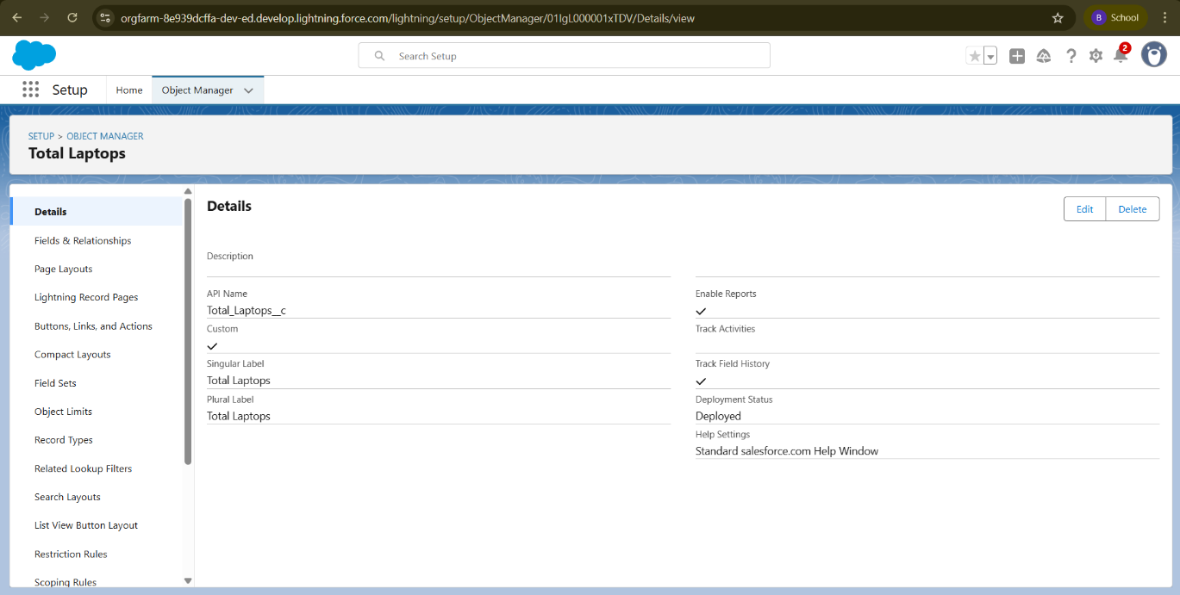

# Create ****Consumer**** Object

### Steps:

1. Go to **Setup** → **Object Manager** → **Create** → **Custom Object**.
2. Enter details:
   * **Label Name** → Consumer
   * **Plural Label Name** → Consumer
3. Define **Record Name**:
   * **Record Name** → consumer_name
   * **Data Type** → Name
4. Select options:
   * Allow Reports
   * Allow Search
   * Track Field History
5. Click **Save**.

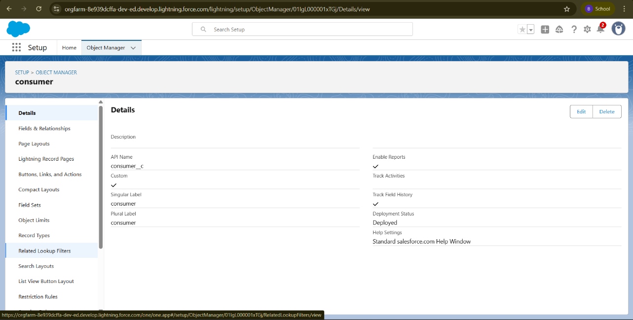

# Create ****Laptop Bookings**** Object

### Steps:

1. Go to **Setup** → **Object Manager** → **Create** → **Custom Object**.
2. Enter details:
   * **Label Name** → Laptop Bookings
   * **Plural Label Name** → Laptop Bookings
3. Define **Record Name**:
   * **Record Name** → Laptop Bookings
   * **Data Type** → Name
4. Select options:
   * Allow Reports
   * Allow Search
   * Track Field History
5. Click **Save**.

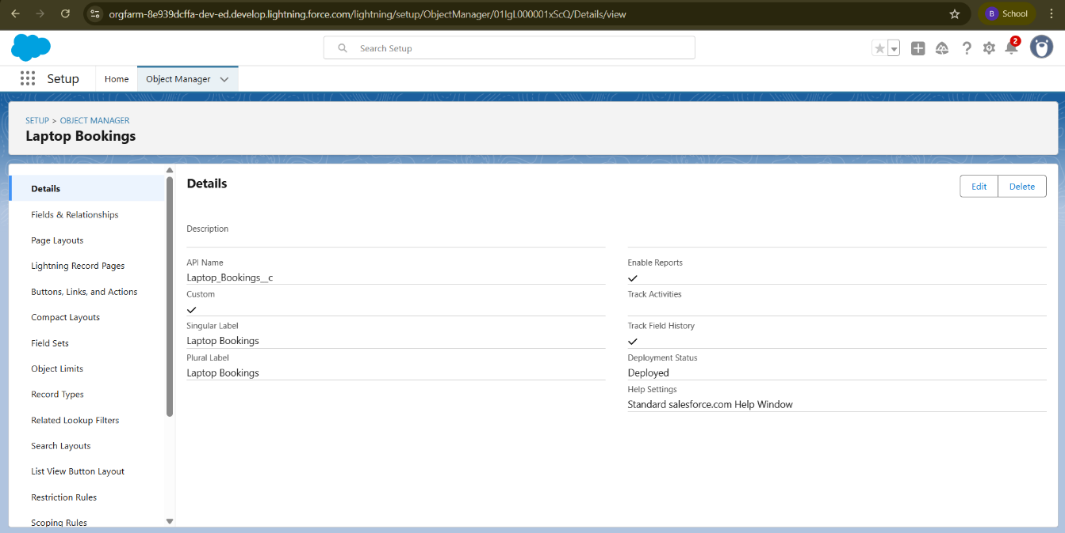

# Create ****Billing Process**** Object

### Steps:

1. Go to **Setup** → **Object Manager** → **Create** → **Custom Object**.
2. Enter details:
   * **Label Name** → Billing Process
   * **Plural Label Name** → Billing Process
3. Define **Record Name**:
   * **Record Name** → Billing ProcessName
   * **Data Type** → Name
4. Select options:
   * Allow Reports
   * Allow Search
   * Track Field History
5. Click **Save**.

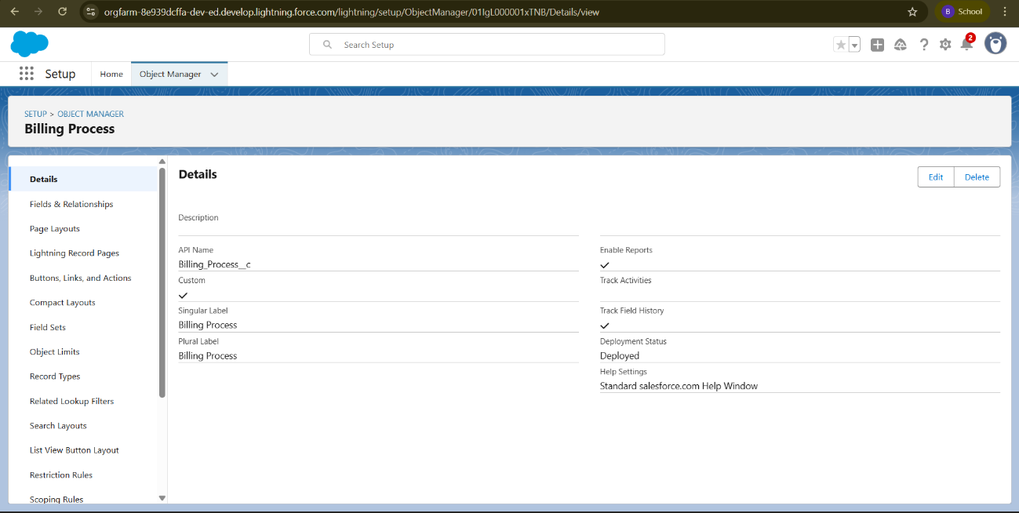

**5. Tabs**

**5.1 What is a Tab?**

A **Tab** in Salesforce is a **user interface element** that allows users to create, view, and manage records of an object. Tabs act as navigation items in Salesforce apps, giving users direct access to data and custom applications.

**5.2 Types of Tabs**

1. **Custom Object Tabs**
   * Used for **Custom Objects** created by users.
   * Look and function like standard tabs such as *Accounts* or *Contacts*.
2. **Web Tabs**
   * Display **external web content or applications** inside the Salesforce interface.
   * Useful for quick access to websites or tools without leaving Salesforce.
3. **Visualforce Tabs**
   * Display a **Visualforce Page** inside Salesforce.
   * Provide advanced UI and customization options.
4. **Lightning Component Tabs**
   * Add **Lightning Components** to the navigation menu in Lightning Experience or Salesforce Mobile App.
   * Provide modern, component-based UI features.

**Creating Custom Tabs**

**Activity 1: Create Tab for Total Laptops**

1. Go to **Setup** → In **Quick Find**, type **Tabs** → Click **Tabs**.
2. Under **Custom Object Tabs**, click **New**.
3. Select **Object** → *Total Laptops*.
4. Choose a **Tab Style**.
5. Click **Next** → On **Add to Profiles**, keep default.
6. Click **Next** → On **Add to Custom Apps**, **uncheck Include Tab**.
7. Check **Append tab to users’ existing personal customizations**.
8. Click **Save**.

Tab for **Total Laptops** created successfully.

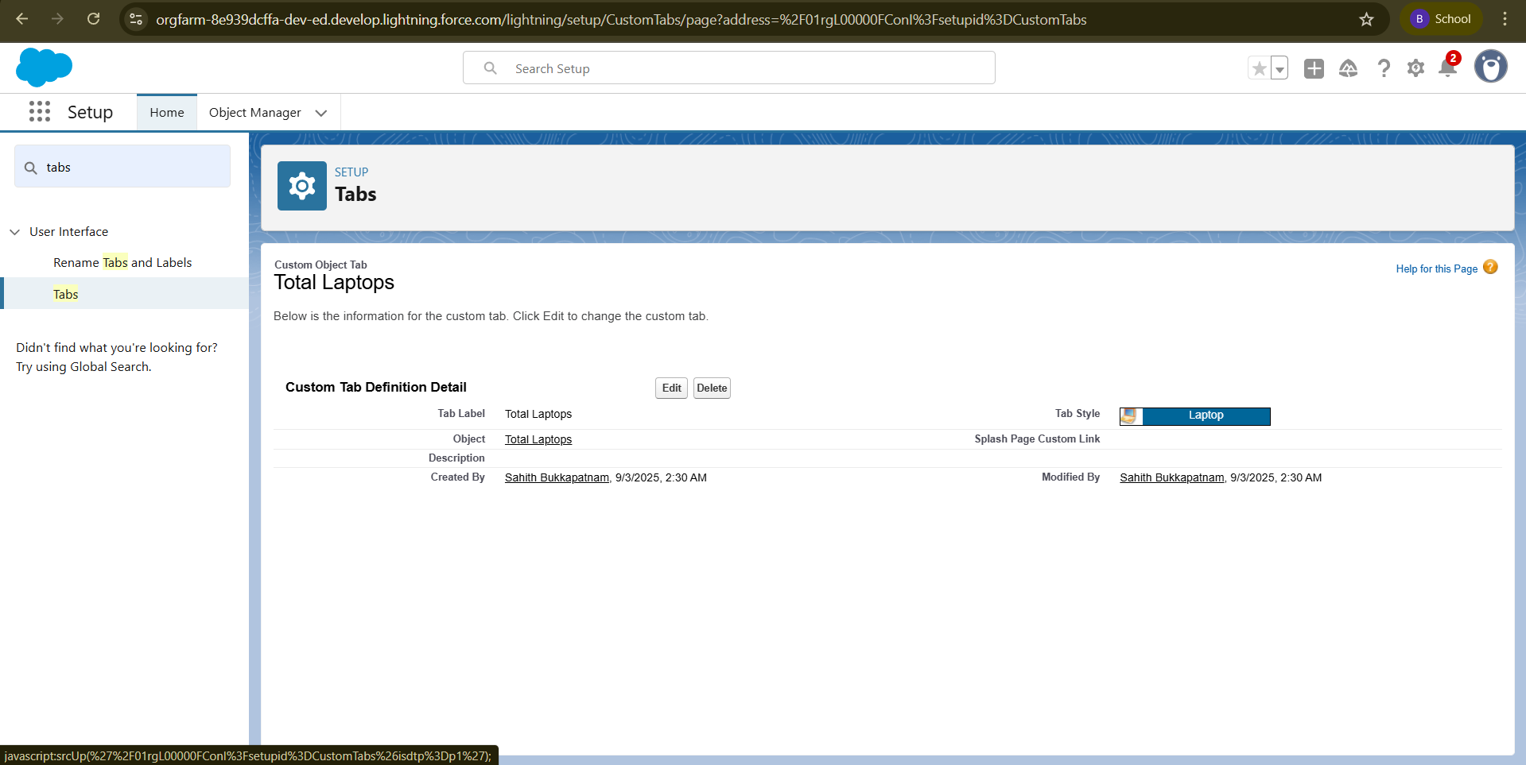

**Activity 2: Creating Remaining Tabs**

Repeat the **same steps as Activity 1** to create tabs for the following objects:

* **Consumer**
* **Laptop Bookings**
* **Billing Process**

Tabs for **Consumer, Laptop Bookings, and Billing Process** created successfully

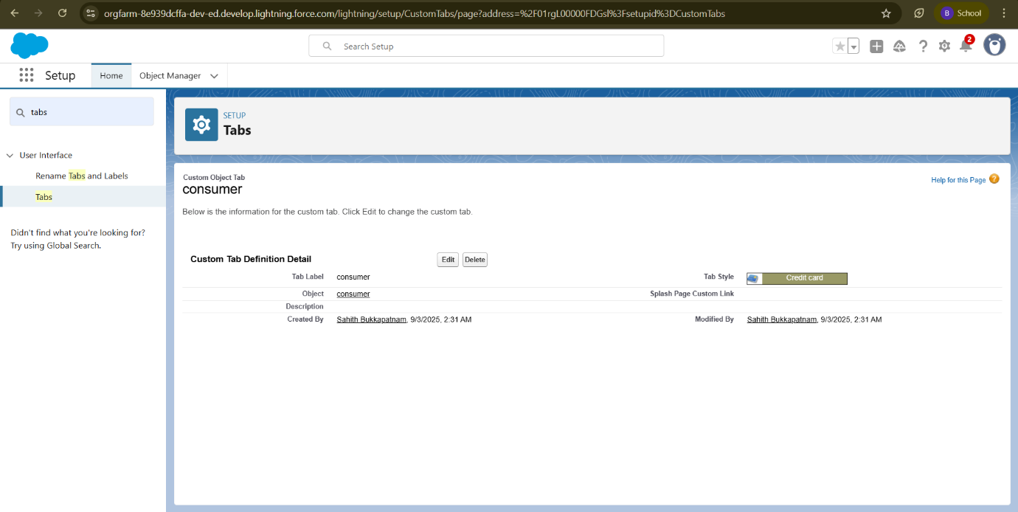

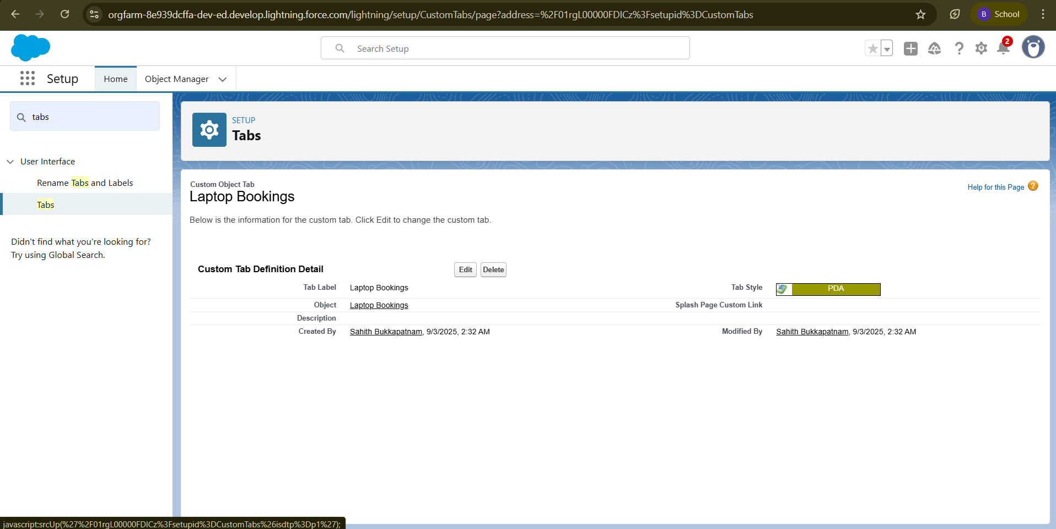

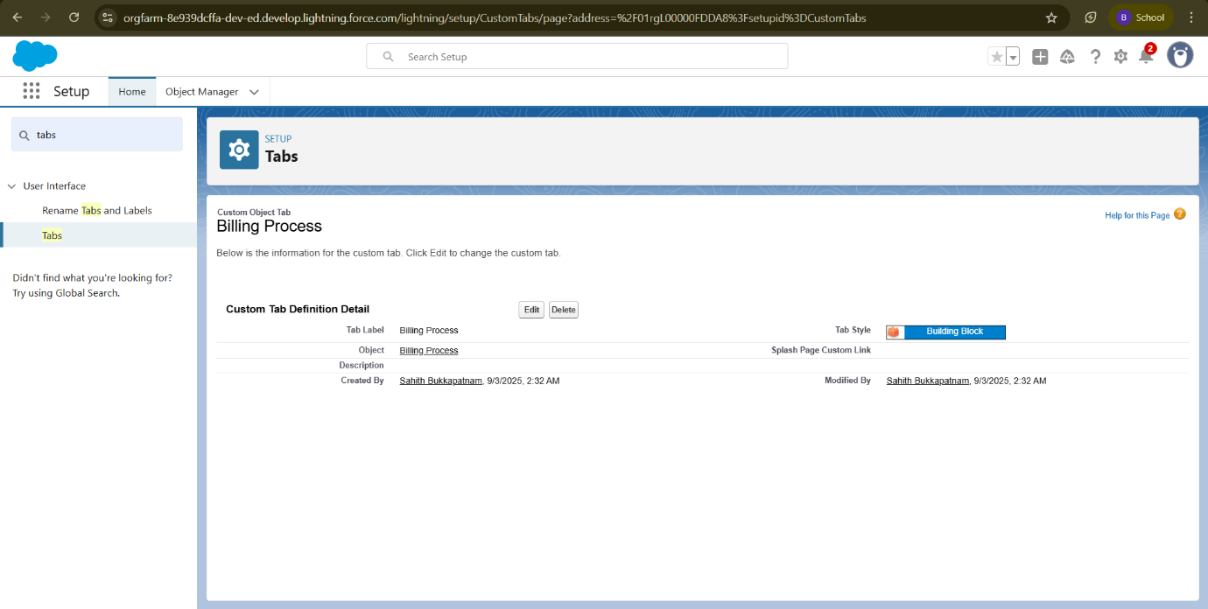

## 6. The Lightning App

### 6.1 What is a Lightning App?

A **Lightning App** in Salesforce is a collection of items such as **objects, tabs, utilities, and custom pages** grouped together to serve a specific business function. In **Lightning Experience**, Lightning Apps appear in the **navigation bar**, making it easy for users to access the tools they need in one place.

For the **Laptop Rentals CRM**, a dedicated Lightning App can be created to bundle objects like:

* **Total Laptops**
* **Consumer**
* **Laptop Bookings**
* **Billing Process**

This ensures users can quickly navigate between core CRM functions.

# Create a Lightning App

### Steps:

1. Go to **Setup** → In **Quick Find**, type **App Manager** → Select **App Manager**.
2. Click **New Lightning App**.

#### App Details

* Enter **App Name** → LAPTOP RENTALS.
* Click **Next**.

#### App Options

* Keep all defaults → **Next**.

#### Utility Items

* Keep defaults → **Next**.
* Upload a **photo/logo** related to the app.

#### Navigation Items

* From the search bar, select and move these objects:
  + **Total Laptops**
  + **Consumer**
  + **Laptop Bookings**
  + **Billing Process**
* Click **Next**.

#### User Profiles

* Search for **System Administrator** profile.
* Move it using the arrow button.
* Click **Save & Finish**.

Lightning App “LAPTOP RENTALS” created successfully with navigation items for Total Laptops, Consumer, Laptop Bookings, and Billing Process.

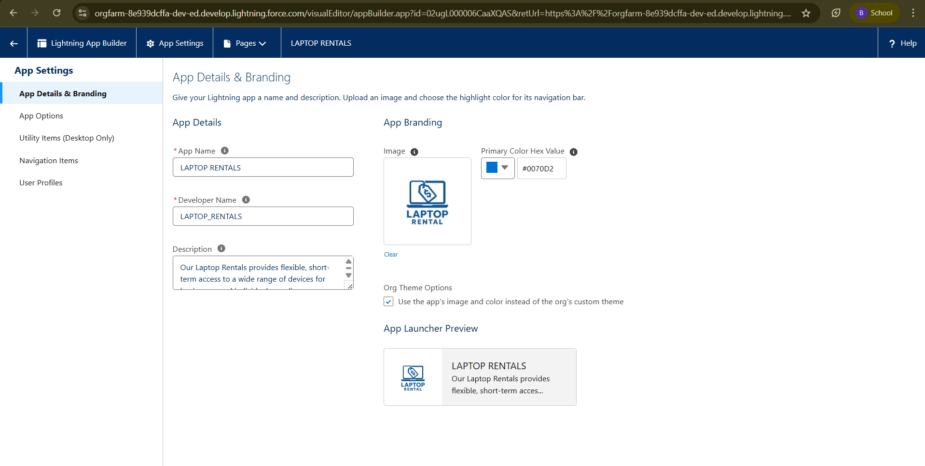

## 7. Fields

### 7.1 What are Fields?

In Salesforce, **Fields** represent the individual pieces of data stored in an object. They are equivalent to **columns in a relational database table**. Each record (row) in an object stores values in these fields.

Fields allow users to store, search, edit, and report on specific pieces of information, making record management simpler and more efficient.

### 7.2 Types of Fields

#### 1. **Standard Fields**

* Predefined by Salesforce and available in every object.
* Cannot be deleted (except some optional ones).

#### 2. **Custom Fields**

* Defined by users to capture **business-specific data**.
* Fully customizable: you can **create, modify, or delete** as needed.
* Flexible data types: Text, Number, Date, Checkbox, Lookup, Picklist, etc.

**Creating Fields in Consumer Object**

**Step 1: Create Phone Number Field**

1. Go to **Setup** → **Object Manager**.
2. Search and select **Consumer** object.
3. Navigate to **Fields & Relationships** → **New**.
4. Select **Phone** as Data Type → **Next**.
5. Fill details:
   * **Field Label:** Phone Number
   * **Field Name:** Auto-generated
   * Select **Required**.
6. Click **Next → Next → Save & New**.

**Step 2: Create Email Field**

1. From Consumer → **Fields & Relationships** → **New**.
2. Select **Email** as Data Type → **Next**.
3. Fill details:
   * **Field Label:** Email
   * **Field Name:** Auto-generated
4. Click **Next → Next → Save & New**.

**Step 3: Create Address Field**

1. From Consumer → **Fields & Relationships** → **New**.
2. Select **Text Area** → **Next**.
3. Fill details:
   * **Field Label:** Address
   * **Field Name:** Auto-generated
   * Mark as **Required**.
4. Click **Next → Next → Save & New**.

**Step 4: Create Consumer Status Picklist**

1. From Consumer → **Fields & Relationships** → **New**.
2. Select **Picklist** → **Next**.
3. Fill details:
   * **Field Label:** Consumer Status
   * **Field Name:** Auto-generated
   * **Values:**
     + Student
     + Employee
     + Others
   * Mark as **Required**.
4. Click **Next → Next → Save**.

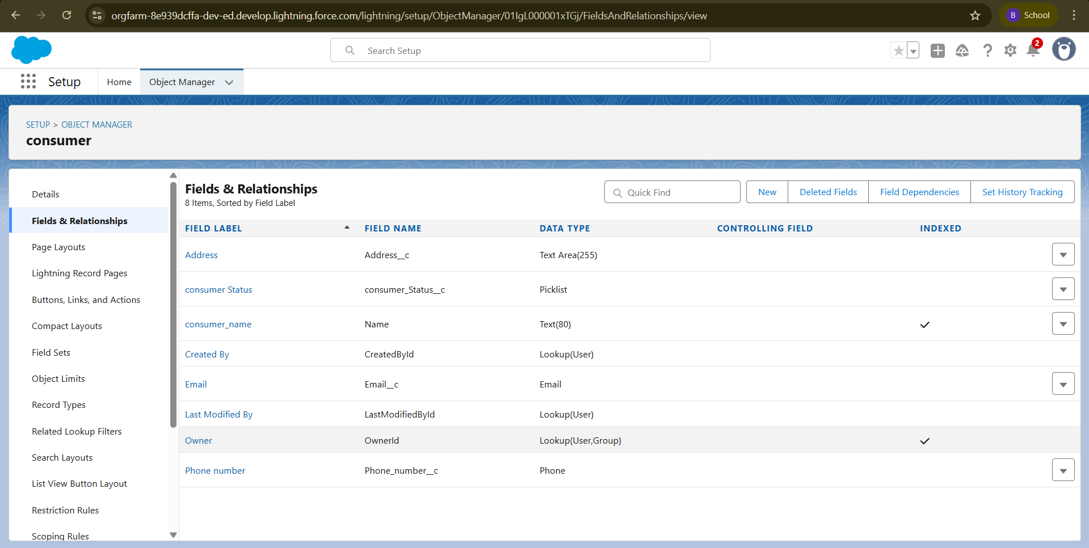

**Creating Fields in Laptop Bookings Object**

**Step 1: Create Laptop Names Picklist Field**

1. Go to **Setup** → **Object Manager**.
2. Search for **Laptop Bookings** object → Click it.
3. Navigate to **Fields & Relationships** → **New**.
4. Select **Picklist** → **Next**.
5. Fill details:
   * **Field Label:** Laptop Names
   * **Values:**
     1. Dell
     2. Acer
     3. HP
     4. Mac
   * Select **Required**.
6. Click **Next → Next → Save & New**.

**Step 2: Create Core Type Picklist Field**

1. From **Laptop Bookings** → **Fields & Relationships** → **New**.
2. Select **Picklist** → **Next**.
3. Fill details:
   * **Field Label:** Core Type
   * **Values:**
     1. Core i3
     2. Core i5
     3. Core i7
     4. Bionic Chip
   * Select **Required**.
4. Click **Next → Next → Save**.

**Step 3: Create Field Dependency (Laptop Names → Core Type)**

1. In **Laptop Bookings Object**, go to **Field Dependencies**.
2. Click **New**.
3. Set fields:
   * **Controlling Field:** Laptop Names
   * **Dependent Field:** Core Type
4. Configure dependencies:
   * Dell → Core i3, Core i5, Core i7
   * Acer → Core i3, Core i5, Core i7
   * HP → Core i3, Core i5, Core i7
   * Mac → Bionic Chip
5. Click **Save**.

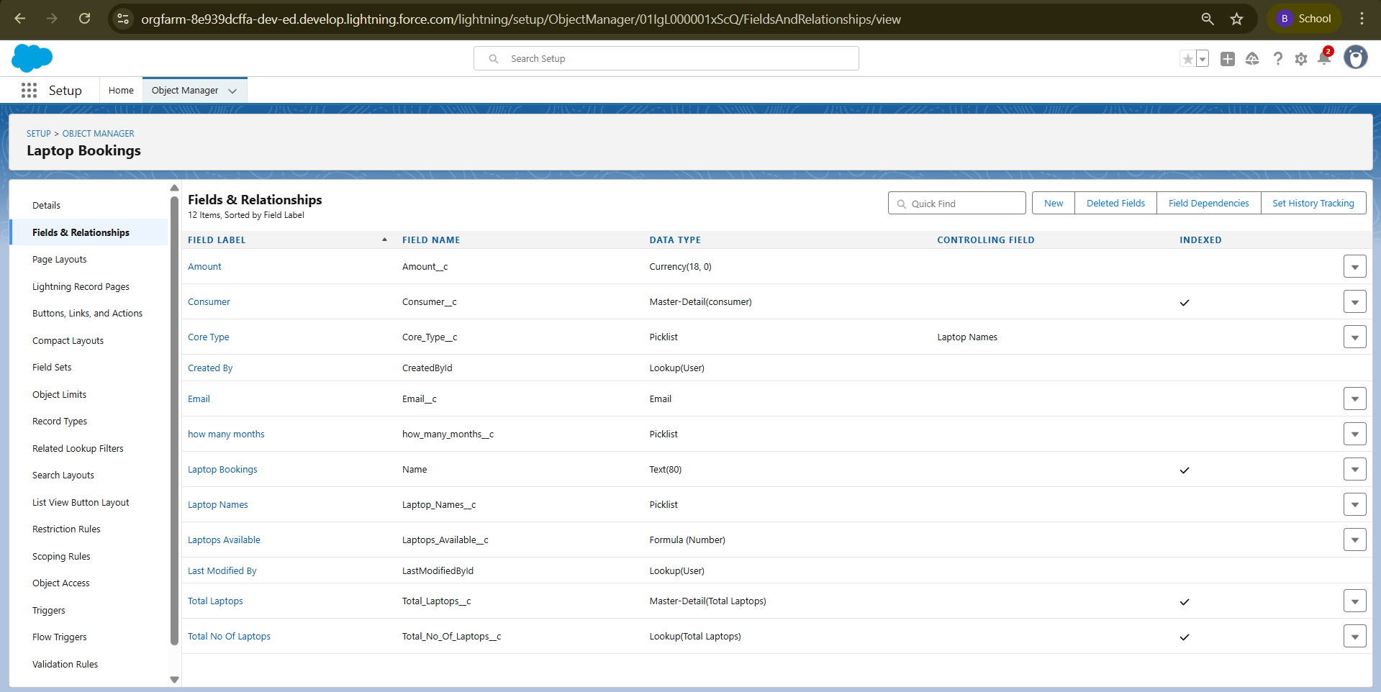

**Fields & Relationships in Laptop Booking and Total Laptops Objects**

**Step 1: Create Master-Detail Relationship (Laptop Booking → Consumer)**

1. Go to **Setup** → **Object Manager** → search **Laptop Booking** → open object.
2. Navigate to **Fields & Relationships** → **New**.
3. Select **Master-Detail Relationship** → **Next**.
4. **Related To:** Consumer object → **Next**.
5. Fill details:
   * **Field Label:** Consumer
   * **Field Name:** Auto-generated
6. Click **Next → Next → Save & New**.

**Step 2: Create Currency Field (Amount in Laptop Booking)**

1. From **Laptop Booking** → **Fields & Relationships** → **New**.
2. Select **Currency** → **Next**.
3. Fill details:
   * **Field Label:** Amount
   * **Length:** 18,0
   * **Field Name:** Auto-generated
4. Click **Next → Next → Save & New**.

**Step 3: Create Lookup Relationship (Laptop Booking → Total Laptops)**

1. From **Laptop Booking** → **Fields & Relationships** → **New**.
2. Select **Lookup Relationship** → **Next**.
3. **Related To:** Total Laptops object → **Next**.
4. Fill details:
   * **Field Label:** Total No of Laptops
   * **Field Name:** Auto-generated
5. Click **Next → Next → Save & New**.

**Step 4: Create Email Field (Laptop Booking)**

1. From **Laptop Booking** → **Fields & Relationships** → **New**.
2. Select **Email** → **Next**.
3. Fill details:
   * **Field Label:** Email
   * **Field Name:** Auto-generated
4. Click **Next → Save**.

**Step 5: Create Roll-up Summary Field (Total Laptops Object)**

Roll-up Summary is available only because of the **Master-Detail Relationship (Consumer–Laptop Booking)**.

1. Go to **Object Manager** → search **Total Laptops** → open object.
2. Navigate to **Fields & Relationships** → **New**.
3. Select **Roll-up Summary** → **Next**.
4. Fill details:
   * **Field Label:** Laptops Delivered
   * **Field Name:** Auto-generated
   * **Summarized Object:** Laptop Bookings
   * **Roll-up Type:** COUNT
5. Click **Next → Save**.

**Step 6: Create Formula Field (Laptop Booking → Laptops Available)**

1. From **Laptop Booking** → **Fields & Relationships** → **New**.
2. Select **Formula** → **Next**.
3. Fill details:
   * **Field Label:** Laptops Available
   * **Field Name:** Auto-generated
   * **Return Type:** Number
   * **Decimal Places:** 0
4. In **Advanced Formula**, enter:
5. 50 - Total_no_of_laptops__r.Laptops_delivered__c
6. Click **Check Syntax → Next → Next → Save**.

**Step 7: Create Picklist Field (Laptop Booking → Rental Duration)**

1. From **Laptop Booking** → **Fields & Relationships** → **New**.
2. Select **Picklist** → **Next**.
3. Fill details:
   * **Field Label:** How Many Months
   * **Values:** 1, 2, 3, 4, 5
   * **Field Name:** Auto-generated
4. Click **Save**.

**Fields & Relationships in Billing Process Object**

**Step 1: Create Master-Detail Relationship (Billing Process → Consumer)**

1. Go to **Setup** → **Object Manager** → search **Billing Process** → open object.
2. Navigate to **Fields & Relationships** → **New**.
3. Select **Master-Detail Relationship** → **Next**.
4. **Related To:** Consumer → **Next**.
5. Fill details:
   * **Field Label:** Name
   * **Field Name:** Auto-generated
6. Click **Next → Next → Save & New**.

**Step 2: Create Lookup Relationship (Billing Process → Laptop Booking)**

1. From **Billing Process** → **Fields & Relationships** → **New**.
2. Select **Lookup Relationship** → **Next**.
3. **Related To:** Laptop Booking → **Next**.
4. Fill details:
   * **Field Label:** Laptop Booking
   * **Field Name:** Auto-generated
5. Click **Next → Next → Save & New**.

**Step 3: Create Payment Mode Picklist**

1. From **Billing Process** → **Fields & Relationships** → **New**.
2. Select **Picklist** → **Next**.
3. Fill details:
   * **Field Label:** Payment Mode
   * **Values:**
     + Cash
     + Check
     + Credit Card
     + Debit Card
     + UPI
     + PhonePe
     + GPay
     + Paytm
   * Select **Required**
4. Click **Next → Next → Save & New**.

**Step 4: Create Cross-Object Formula Field (Amount from Laptop Booking)**

1. From **Billing Process** → **Fields & Relationships** → **New**.
2. Select **Formula** → **Next**.
3. Fill details:
   * **Field Label:** Amount
   * **Field Name:** Auto-generated
   * **Return Type:** Currency
4. In **Advanced Formula**, insert field:
5. Laptop_Booking__r.Amount__c
6. Click **Check Syntax** → No errors → **Next → Next → Save**.

**Creating Fields in Total Laptops Object**

**Step 1: Create Laptops Available Formula Field**

1. Go to **Setup** → **Object Manager** → search **Total Laptops** → open object.
2. Navigate to **Fields & Relationships** → **New**.
3. Select **Formula** → **Next**.
4. Fill details:
   * **Field Label:** Laptops Available
   * **Field Name:** Auto-generated
   * **Return Type:** Number
   * **Decimal Places:** 0
5. Click **Next**.
6. In **Advanced Formula**, enter:
7. 50 - Laptops_delivered__c

**Note:** Assumes total laptops = 50 when creating a new record.

1. Click **Check Syntax** → No errors → **Next → Next → Save & New**.

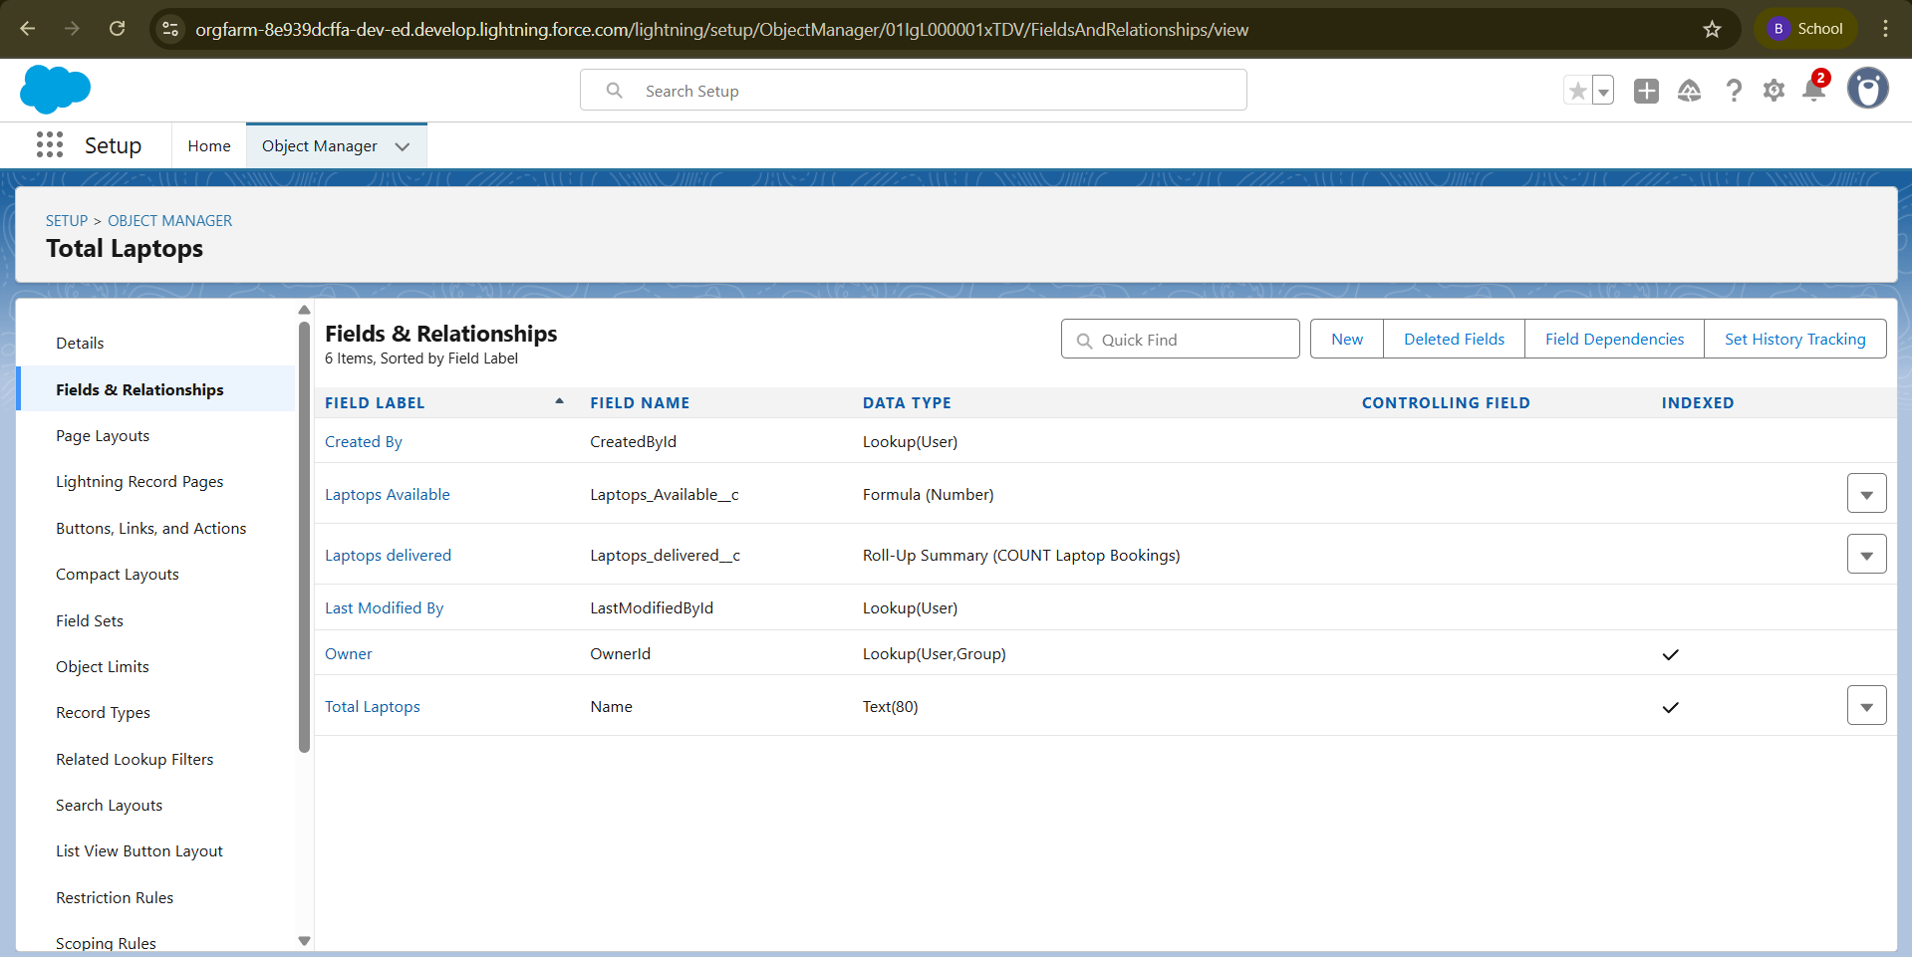

# 8. Validation Rule

### 8.1 What is a Validation Rule?

A **Validation Rule** ensures that the data entered by users meets specified criteria before a record can be saved.

* If the criteria are **not met**, Salesforce displays an **error message** and prevents the record from being saved.
* Validation rules use **formulas** that evaluate to **TRUE** (invalid data) or **FALSE** (valid data).
* They help **improve data quality** and maintain consistency in your records.

**Validation Rule in Consumer Object**

**Steps:**

1. Go to **Setup** → **Object Manager** → Select **Consumer** → Click **Edit**.
2. Navigate to **Validation Rules** → Click **New**.
3. Fill in the details:
   * **Rule Name:** Phonenumberoremailblankrule
   * **Description:** Phone number and email number should not be blank
4. Enter the **Formula**:
5. OR(ISBLANK(phone_number__c), ISBLANK(email__c))
6. Click **Check Syntax** → Ensure there are no errors.
7. Click **Save**.

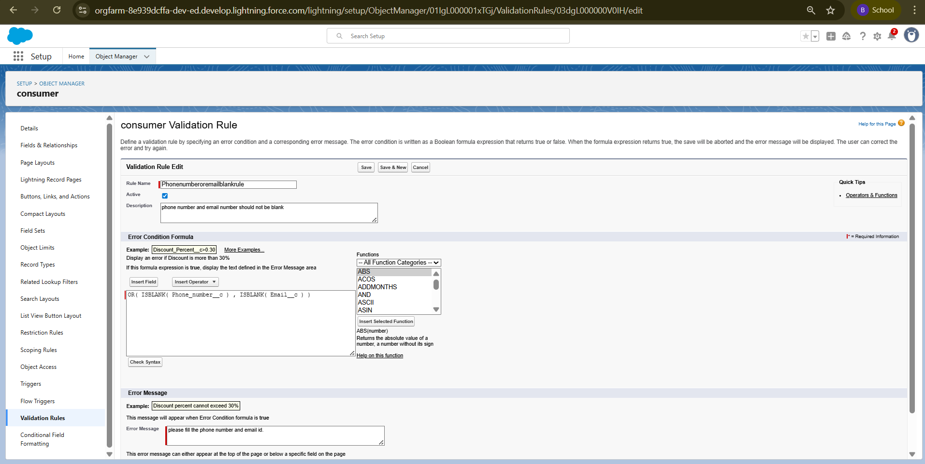

**9. Profiles**

**9.1 What is a Profile?**

A **Profile** in Salesforce is a collection of settings and permissions that control what users can do in the platform. Profiles define access to objects, fields, tabs, apps, and other features.

Profiles ensure that users have the correct access level according to their role in the organization.

**9.2 Types of Profiles**

**Standard Profiles (provided by Salesforce)**

* Marketing User
* Solutions Manager
* Standard User
* System Administrator

🔹 These cannot be deleted. They come with predefined permissions for standard Salesforce objects.

**Custom Profiles (created by admins)**

* Defined based on business requirements.
* Can be deleted if no users are assigned.
* Useful for tailoring access to **custom apps and objects**.

**Owner Profile**

**Steps:**

1. Go to **Setup → Quick Find → Profiles**.
2. Select a profile to clone (e.g., **Standard User**) → Click **Clone**.
3. Fill in the details:
   * **Profile Name:** Owner
4. Click **Save**.
5. Scroll down to **Custom Object Permissions**.
6. Provide **Read, Create, Edit, Delete** access for:
   * Total Laptops
   * Consumer
   * Laptop Bookings
   * Billing Process
7. Click **Save**.

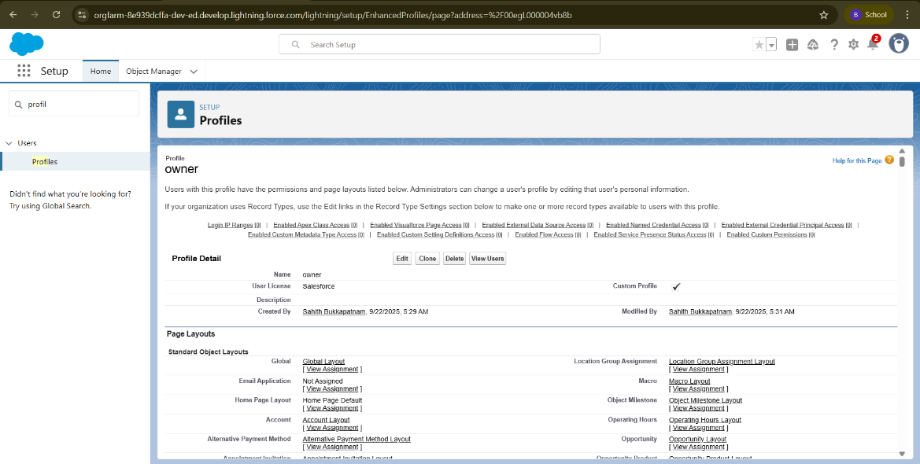

**Agent Profile**

**Steps:**

1. Go to **Setup → Quick Find → Profiles**.
2. Select a profile to clone (e.g., **Standard Platform User**) → Click **Clone**.
3. Fill in the details:
   * **Profile Name:** Agent
4. Click **Save**.
5. On the profile page → Click **Edit**.
6. Scroll down to **Custom Object Permissions**.
7. Provide access for the following objects:
   * **Total Laptops**
   * **Consumer**
   * **Laptop Bookings**
   * **Billing Process**
8. Click **Save**.

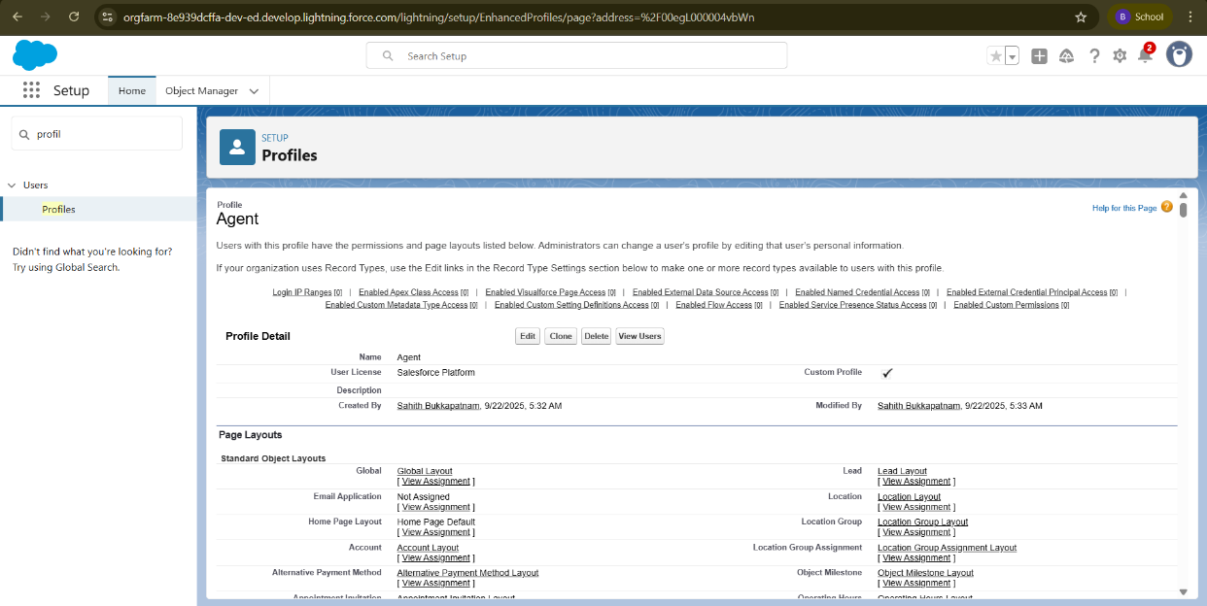

**10. Roles and Hierarchy**

**10.1 What is a Role?**

A **Role** in Salesforce defines a user's **visibility access at the record level**.

* Roles specify what data users can **see and access** within the Salesforce organization.
* Roles work together with **profiles** to control **record-level security**.

**10.2 Purpose of Roles**

* Control **data visibility** across the organization.
* Help implement **record-level security** using **role hierarchy**.
* Allow users to access records **owned by or shared with subordinates**.

**Creating Owner and Agent Roles**

**Steps:**

**Creating Owner Role**

1. Go to **Quick Find → Search for Roles → Click Setup Roles**.
2. Click **Expand All** → Click **Add Role** under the appropriate parent role.
3. Fill in the details:
   * **Label:** Owner
   * **Role Name:** Auto-populated
4. Click **Save**.

**Creating Agent Roles**

1. Go to **Quick Find → Search for Roles → Click Setup Roles**.
2. Click **Plus** on the **CEO** role → Click **Add Role** under **Owner**.
3. Fill in the details:
   * **Label:** Agent
   * **Role Name:** Auto-populated
4. Click **Save**.

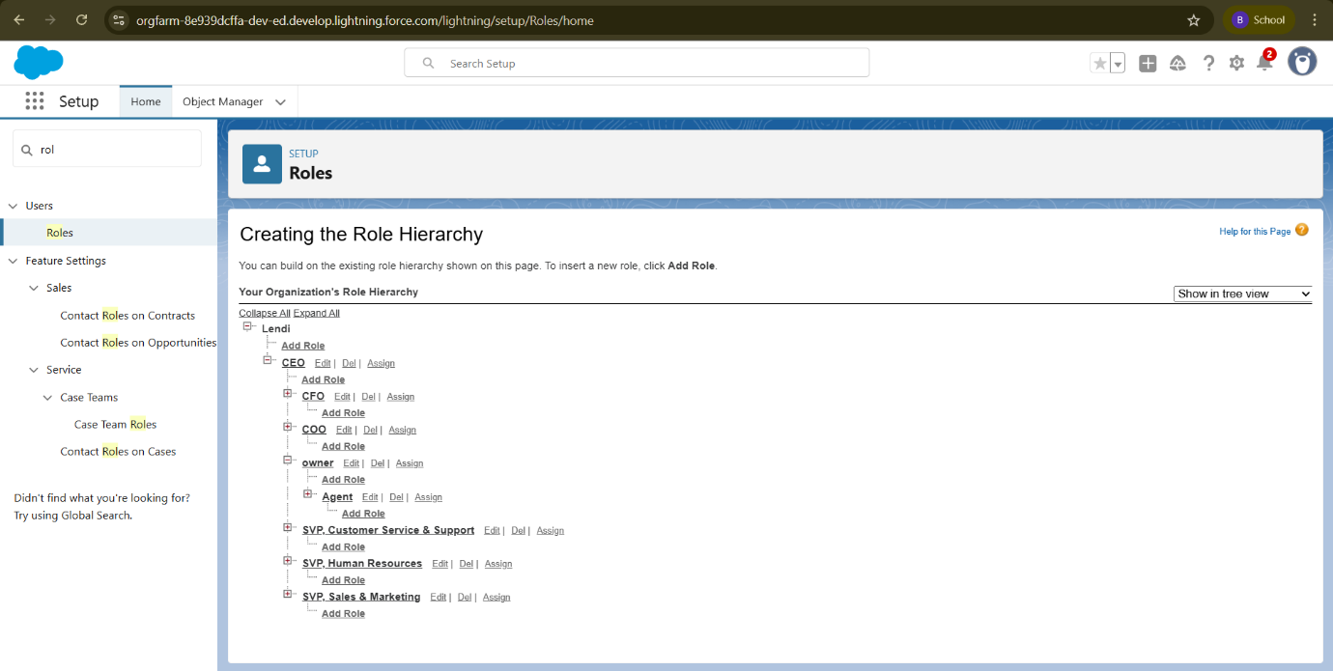

**11. Users**

**11.1 What is a User?**

A **User** is anyone who logs in to Salesforce.

* Users can be employees such as sales reps, managers, or IT specialists.
* Every user in Salesforce has a **user account**, which:
  + Identifies the user
  + Determines what features and records the user can access

**Create User**

**Activity 1: Creating Owner User**

**Steps:**

1. Go to **Setup → Quick Find → Users → Click New User**.
2. Fill in the fields:
   * **First Name:** Vicky
   * **Last Name:** Y
   * **Alias:** Provide an alias name
   * **Email ID:** Personal email ID
   * **Username:** text@text.text
   * **Nickname:** Provide a nickname
   * **Role:** Owner
   * **User License:** Salesforce
   * **Profile:** Owner
3. Click **Save**.

**Activity 2: Creating Agent User**

**Steps:**

1. Go to **Setup → Quick Find → Users → Click New User**.
2. Fill in the fields:
   * **First Name:** Ram
   * **Last Name:** Ram
   * **Alias:** Provide an alias name
   * **Email ID:** Personal email ID
   * **Username:** text@text.text
   * **Nickname:** Provide a nickname
   * **Role:** Agent
   * **User License:** Salesforce Platform
   * **Profile:** Agent
3. Click **Save**.

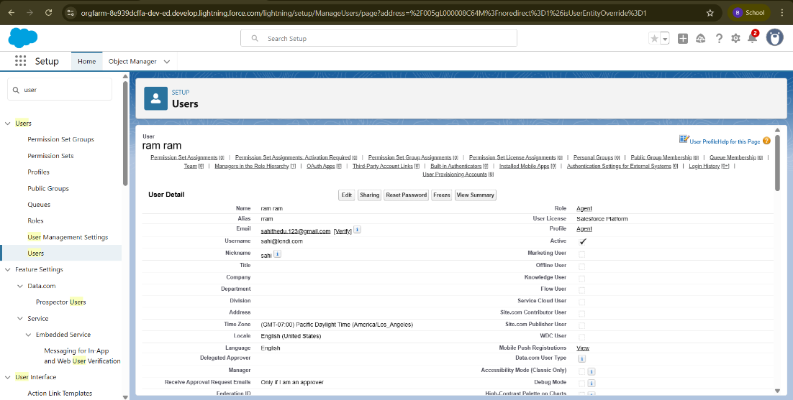

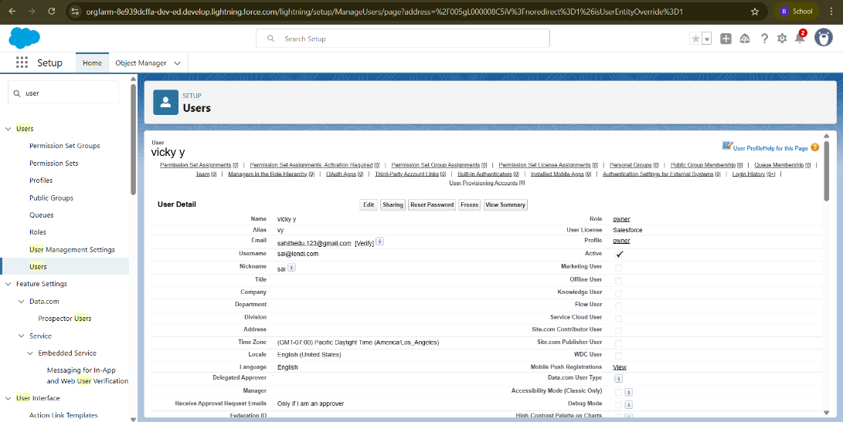

**12. Flows**

**12.1 What is a Flow?**

A **Flow** in Salesforce is a **powerful automation tool** that allows you to:

* Automate business processes
* Collect and update data
* Guide users through a series of screens or steps

Flows are built using a **visual interface** and require **no coding knowledge**.

**12.2 Types of Flows**

1. **Screen Flows** – Guide users through screens to collect or display data.
2. **Autolaunched Flows** – Triggered by events (record creation/update) without user interaction.
3. **Scheduled Flows** – Run at specific times or intervals for recurring tasks.
4. **Record-Triggered Flows** – Triggered when records meet specified criteria.
5. **Subflows** – Reusable flows incorporated into multiple flows.

**12.3 Flow Builder**

* A **drag-and-drop visual interface** used to design flows.
* Allows adding elements like **screens, logic, variables, loops, and decisions**.
* Supports **Flow Templates** for quick creation of common processes.

**Creating Flows on Dell, Acer, Hp, Mac laptops**

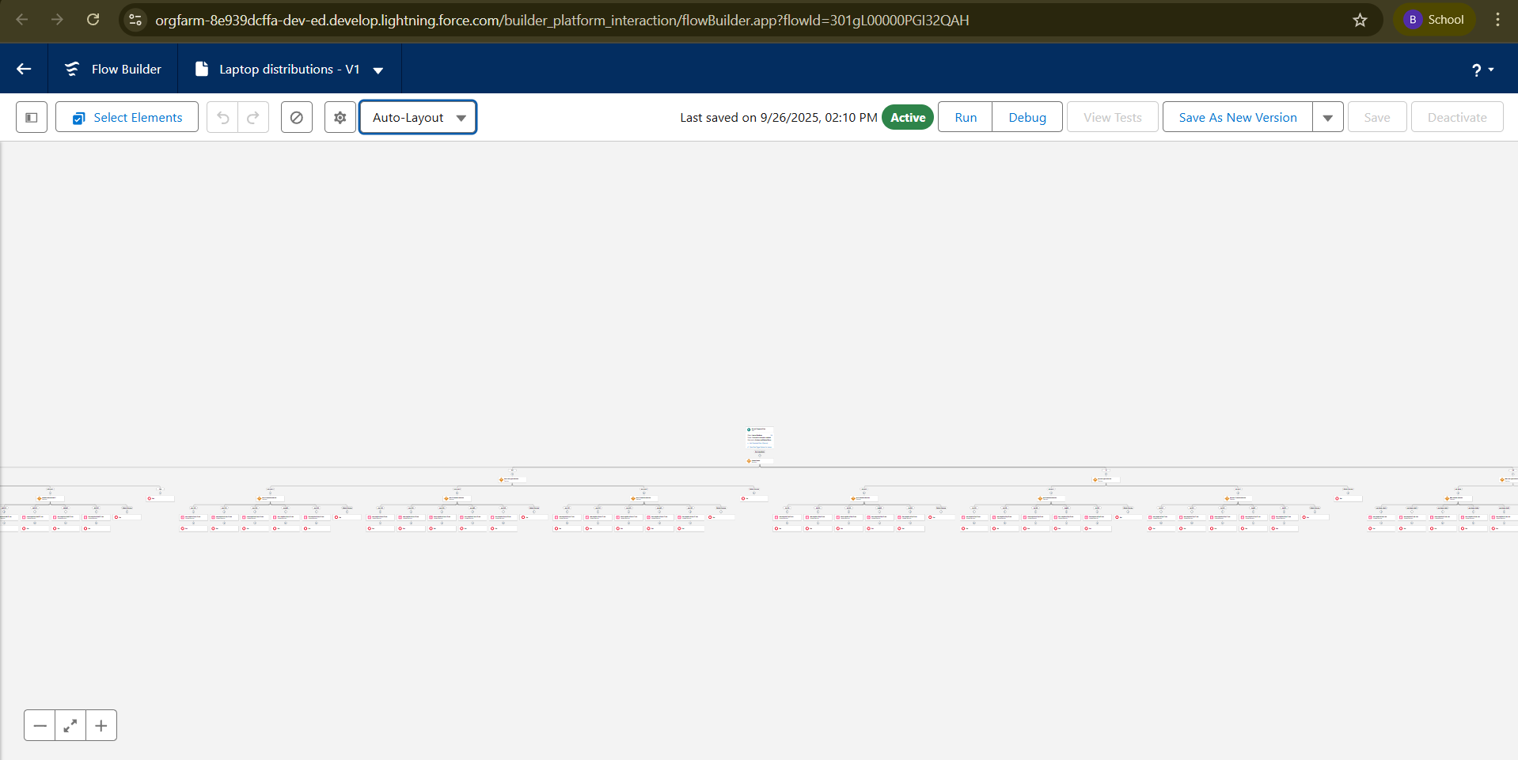

**13. APEX**

**13.1 Overview**

Apex is a **strongly typed, object-oriented programming language** for the Salesforce platform.

* Allows developers to **execute flow and transaction control statements** on the server.
* Syntax is **similar to Java** and acts like database stored procedures.
* Enables adding **business logic** to system events, button clicks, triggers, and Visualforce pages.
* Apex can be initiated by **web service requests** or **triggers** on objects.

**13.2 Apex and OOP Concepts**

* **Class:** Template or blueprint from which objects are created.
* **Object:** Instance of a class; can access class properties and methods.
* Supports **Object-Oriented Programming**: classes, objects, methods, inheritance.

**13.3 Creating a Class in Apex**

**Steps:**

1. Log in to **Salesforce** → Click the **gear icon** → Open **Developer Console**.
2. In the Developer Console toolbar → Click **File → New → Apex Class**.
3. Enter a **class name** → Click **OK** to create the new class file.

**13.4 Access Specifiers in Apex**

1. **Private:** Accessible only within the class (default).
2. **Protected:** Accessible to inner classes and classes that extend the defining class.
3. **Public:** Accessible by all Apex within a package.
4. **Global:** Accessible by any Apex code outside the application; the class must also be global.

**13.5 Triggers**

A **trigger** is a set of Apex code that runs **before or after DML events** (insert, update, delete).

**Trigger Types:**

* **Before Triggers:** Run **before database changes**; useful for validation.
* **After Triggers:** Run **after database changes**; useful for updating related records.

**Apex Trigger and Handler Class**

**Activity 1: Creating a New Trigger**

**Steps:**

1. Log in to **Salesforce Trailhead → Gear Icon → Developer Console**.
2. In Developer Console toolbar → Click **File → New → Apex Trigger**.
3. Enter the following details:
   * **Trigger Name:** LaptopBooking
   * **Object:** Laptop_Bookings__c (copy the API name from your org)
4. Click **Submit**.

**Activity 2: Trigger Syntax**

**General Syntax:**

Trigger [TriggerName] on [ObjectName] (Before/After [event]) {

// trigger logic

}

**Trigger Code for Laptop Booking:**

trigger LaptopBooking on Laptop_Bookings__c (After insert, After update) {

if(trigger.isAfter && (trigger.isInsert || trigger.isUpdate)) {

LaptopBookingHandler.sendEmailNotification(trigger.new);

}

}

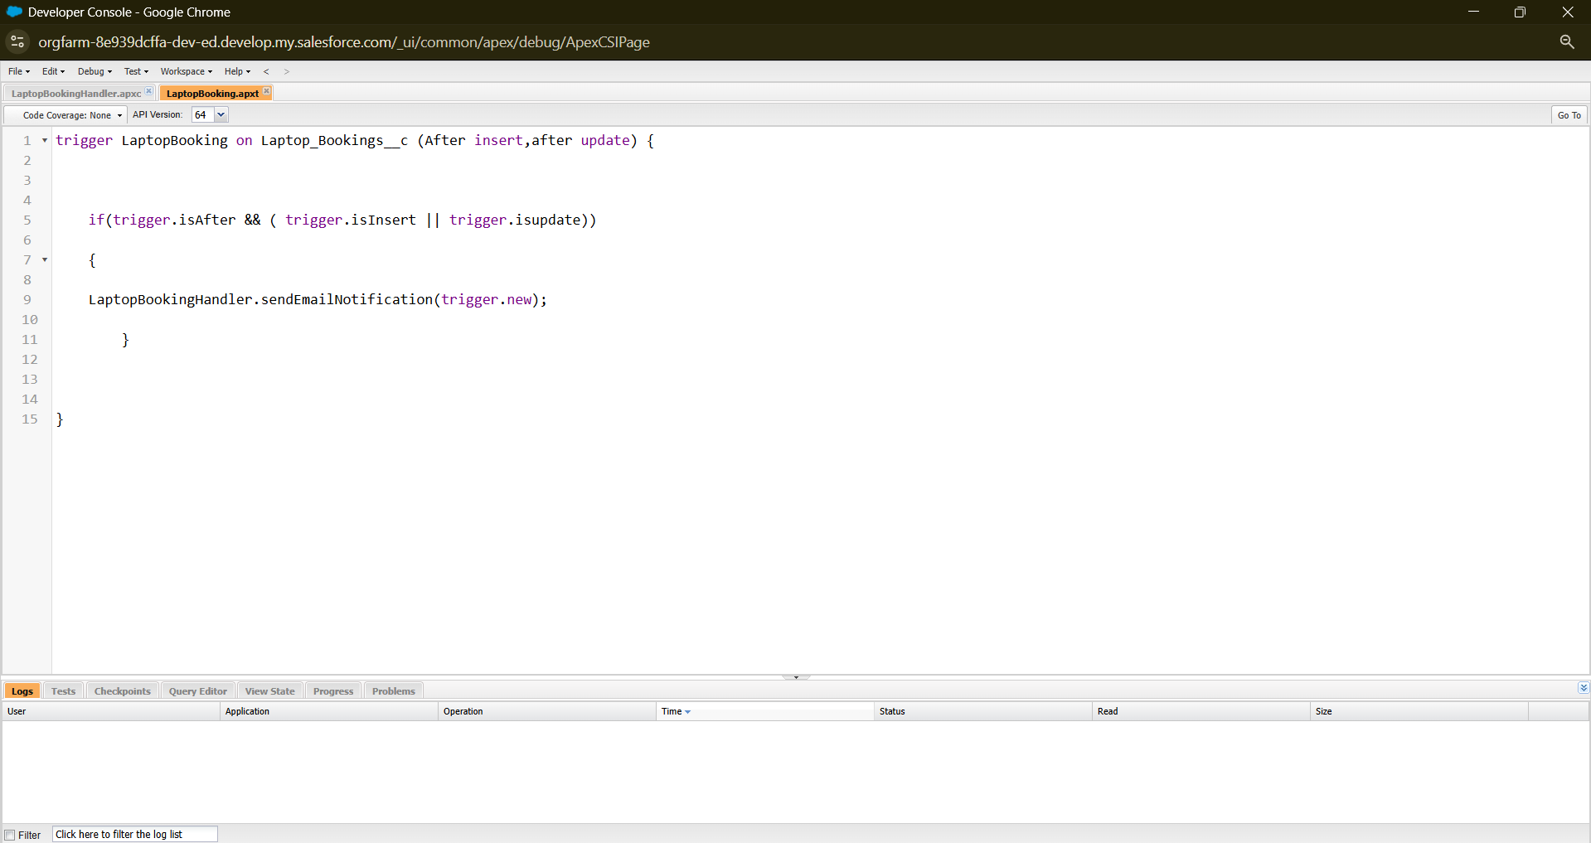

**Activity 3: Creating Handler Class**

**Steps:**

1. In Developer Console → **File → New → Apex Class**.
2. Enter Class Name: LaptopBookingHandler → Click **OK**.
3. Copy and paste the following code:

public class LaptopBookingHandler {

public static void sendEmailNotification(List<Laptop_Bookings__c> lapList){

for(Laptop_Bookings__c lap : lapList){

Messaging.SingleEmailMessage email = new Messaging.SingleEmailMessage();

email.setToAddresses(new List<String>{lap.Email__c});

email.setSubject('Welcome to our company');

String body = 'Dear Customer, \n';

body += 'Welcome to Laptop Rentals! You are a valuable customer.\n';

body += 'Laptop Amount = ' + lap.Amount__c + '\n';

body += 'Core Type = ' + lap.core_type__c + '\n';

body += 'Laptop Type = ' + lap.Laptop_name__c;

email.setPlainTextBody(body);

Messaging.sendEmail(new List<Messaging.SingleEmailMessage>{email});

}

}

}

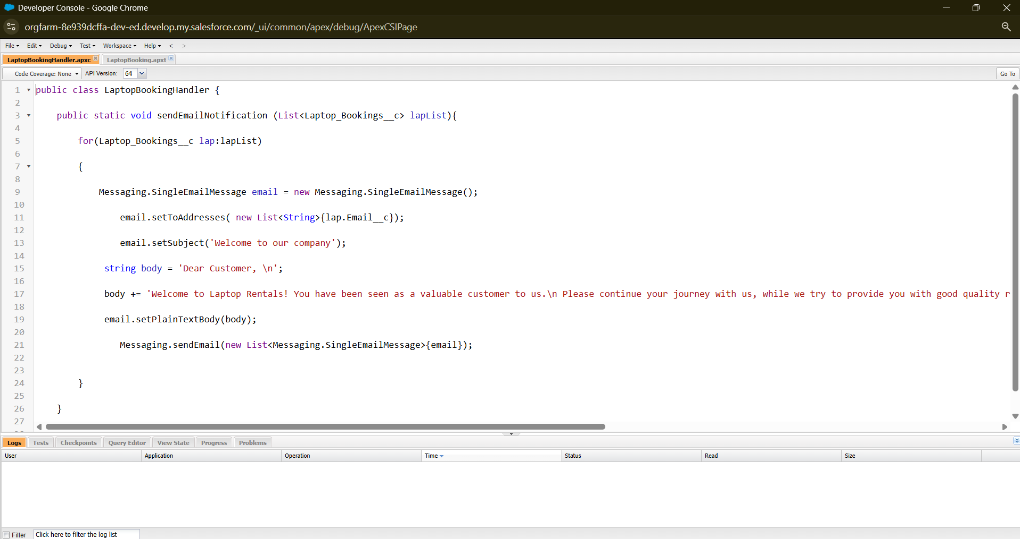

**Activity 4: Trigger Execution**

* The trigger is executed **after a record is inserted or updated**.
* It **automatically sends an email** to the customer with laptop details.
* Ensures **business rules and notifications** are automated.

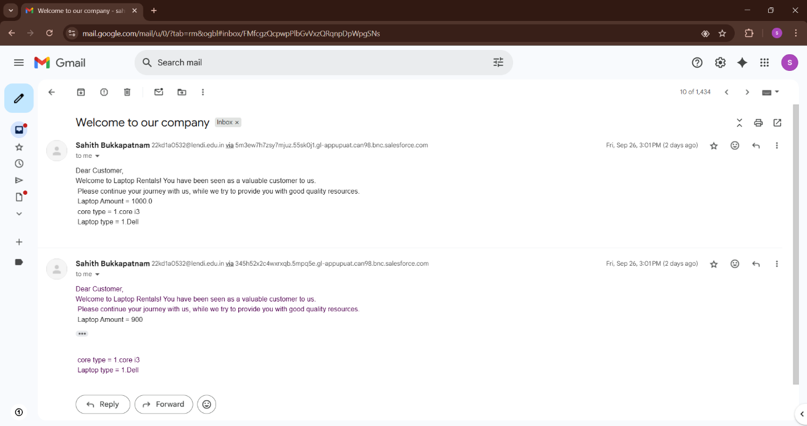

**14. Reports**

**14.1 Overview**

Reports in Salesforce allow you to **access, analyze, and share your Salesforce data**.

* Examine data in various combinations
* Display data in **easy-to-understand formats**
* Schedule and share reports efficiently
* Salesforce provides **powerful analytics tools** to organize, view, and interpret data

**14.2 Types of Reports in Salesforce**

1. **Tabular Reports**
   * Simple listing of data without subtotals
   * Best for a **basic list or grand total**
2. **Summary Reports**
   * Listing of data with **groupings and subtotals**
   * Best for **hierarchical grouping**
3. **Matrix Reports**
   * Group records **by rows and columns**
   * Useful for **comparing totals across two dimensions**
4. **Joined Reports**
   * Combine **blocks of related information** in a single report
   * Each block can have unique **columns, summary fields, formulas, filters, and sort order**

**Create Report**

**Steps:**

1. Go to your **App** → click the **Reports** tab.
2. Click **New Report**.
3. Select report type: search/select **Consumer with Laptop Bookings and Total Laptops** → click **Start Report**.
4. Create a **simple Tabular report**.
5. From the left pane, **add fields** — ensure **Amount** is included.
6. On the **Amount** column → click the dropdown → select **Bucket This Column** (Bucket Field).
7. Define the bucket ranges/categories as required → click **Apply**.
8. To convert into a **Summary report**, set **Group By Rows** → choose **Types of version** (or desired grouping).
9. Click **Save & Run**.

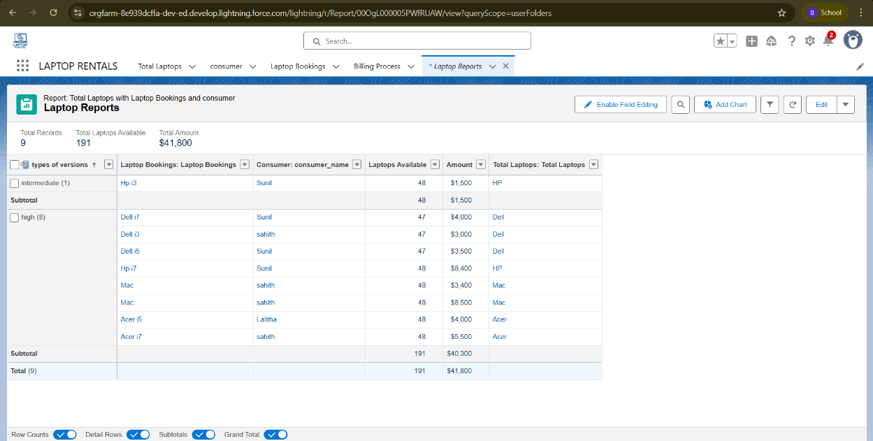

**Sharing Report to Owner**

**Steps:**

1. Open the **Report** you want to share.
2. Click the **Edit** dropdown → select **Subscribe**.
3. In the subscription settings:
   * Select **Run Report As → Another Person**.
   * Choose **Owner** (or the personal account you want to send the report to).
4. Configure frequency/delivery options as needed.
5. Click **Save**.

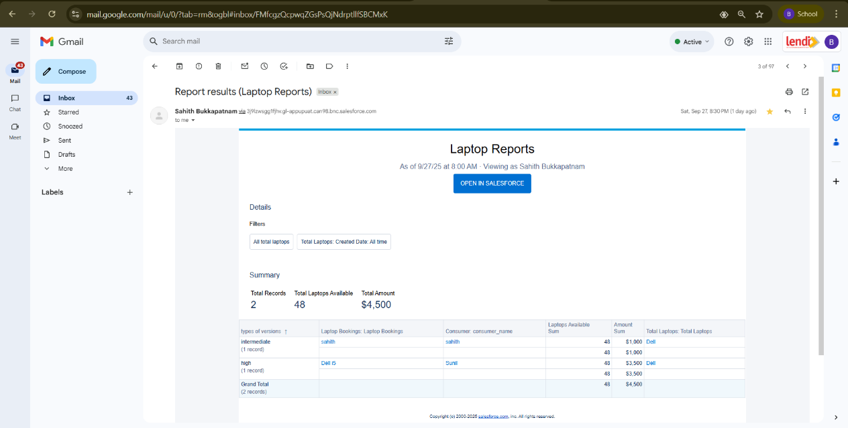

# 15. Dashboards

## 15.1 What is a Dashboard?

A **Dashboard** in Salesforce is a visual representation of your report data. It helps you:

* Track key business metrics in real-time.
* Identify trends and patterns.
* Compare performance across teams or products.
* Make informed decisions based on up-to-date data.

## Creating a Dashboard Folder

### Steps:

1. Go to the **App Launcher** → Search for **Dashboards**.
2. Click on the **Dashboards** tab.
3. Click **New Folder**.
4. Fill in the details:
   * **Folder Label**: Total Rent Amount
   * **Folder Unique Name**: Auto-populated
5. Click **Save**.

## Creating a Dashboard

### Steps:

1. Go to the **App Launcher** → Click on the **Dashboards** tab.
2. Click **New Dashboard**.
3. Fill in the details:
   * **Name**: Enter a dashboard name
   * **Folder**: Select the folder created earlier (**Total Rent Amount**)
4. Click **Create**.
5. Click **+ Add Component**.
6. Select the required **Report** → Click **Select**.
7. Choose the **Dark Component** (chart/graph style) and add it to the dashboard.
8. Click **Save**.
9. Finally, click **Done**.

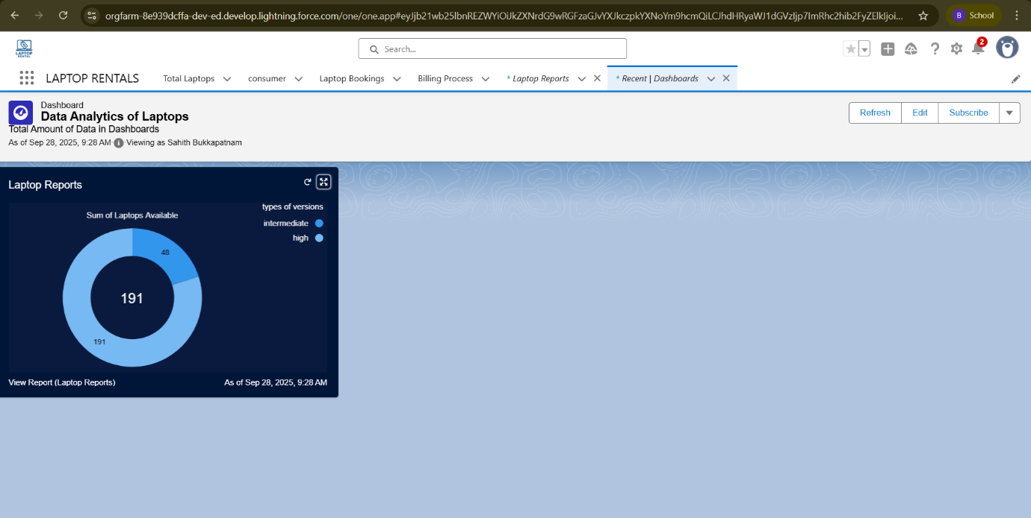

## Summary

This document provides a step-by-step guide for creating and managing Salesforce components such as **objects, fields, relationships, validation rules, profiles, roles, users, flows, Apex classes & triggers, reports, and dashboards**. Each section covers both the **conceptual understanding** (what it is and why it is needed) and the **practical steps** (how to configure it in Salesforce).